

Stella Mary’s College of Engineering

Department of Computer Science and Engineering

Completed the project named as

Predictive Maintenance

Submitted by

R.Shejin-963522104115
T.Vipin Sharone Mony-963522104124
Christobha-9635221040
Belsha Eve Goldy-9635221040
Francina Raj-9635221040

Predictive maintenance revolutionizes traditional maintenance practices by using data analytics and machine learning to anticipate equipment failures. Unlike reactive or scheduled maintenance, it proactively identifies maintenance needs, minimizing downtime and optimizing maintenance schedules. This introduction provides an overview of predictive maintenance's principles and benefits, highlighting its transformative impact on equipment reliability and operational efficiency across industries.
Project Objectives:
The objective of predictive maintenance is to predict when equipment or machinery is likely to fail so that maintenance can be performed just in time. By using various data-driven techniques like machine learning algorithms, sensors, and historical data analysis, predictive maintenance aims to identify patterns or anomalies that indicate potential equipment failures. This proactive approach helps prevent unexpected downtime, reduces maintenance costs, extends the lifespan of equipment, and enhances overall operational efficiency.
System requirements for Predictive Maintenance
Hardware and software requirements for implementing predictive maintenance systems can vary depending on factors such as the scale of operations, the complexity of equipment, and the specific predictive analytics techniques being employed. Here's a breakdown of the hardware and software components typically involved:
Software
- Data Management Software: Software platforms for data management and storage are required to organize, clean, and preprocess data collected from sensors and other sources. This may involve relational databases, NoSQL databases, or big data platforms such as Apache Hadoop or Apache Spark.
- Analytics and Machine Learning Libraries: Software libraries and frameworks for analytics and machine learning are essential for developing and deploying predictive models. This includes libraries for data preprocessing, feature engineering, model training, evaluation, and inference, such as TensorFlow, scikit-learn, and PyTorch.
- Visualization Tools: Visualization tools are necessary for creating interactive dashboards, charts, and reports to visualize predictive maintenance insights and communicate findings to stakeholders effectively. This may involve business intelligence tools, data visualization libraries, or custom-built visualization solutions.
- Edge Computing Software: If edge computing devices are deployed, software for edge computing is required to preprocess data locally, run analytics algorithms, and transmit relevant information to central servers or cloud platforms. This may involve edge computing frameworks such as Apache EdgeX Foundry or Microsoft Azure IoT Edge.
- Monitoring and Alerting Software: Software for real-time monitoring and alerting is necessary to detect anomalies, trigger alerts, and notify maintenance personnel of potential equipment failures. This may involve custom monitoring solutions, open-source monitoring tools, or commercial monitoring platforms.
- Security and Compliance Software: Software for security and compliance management is essential to ensure the confidentiality, integrity, and availability of data in predictive maintenance systems. This may involve identity and access management tools, encryption software, and compliance management platforms.
Methodology
Predictive maintenance relies on a multifaceted approach that combines data collection, analysis, and application of predictive algorithms to anticipate equipment failures and optimize maintenance activities. The methodology typically involves the following key steps:
- Data Acquisition: The first step in predictive maintenance is the collection of relevant data from various sources, including sensors embedded in equipment, historical maintenance records, environmental conditions, and operational parameters. This data is essential for training predictive models and identifying patterns indicative of potential failures.
- Data Preprocessing: Once the data is collected, it undergoes preprocessing to clean and prepare it for analysis. This may involve removing noise, filling in missing values, and standardizing data formats to ensure consistency and accuracy.
- Feature Selection and Engineering: In this step, relevant features or variables that are most predictive of equipment failures are selected or engineered from the raw data. Domain knowledge and statistical techniques are often used to identify the most informative features for predictive modeling.
- Model Evaluation: Trained models are evaluated using validation datasets to assess their accuracy, reliability, and generalization ability. Performance metrics such as precision, recall, F1 score, and area under the receiver operating characteristic curve (AUC-ROC) are commonly used to evaluate predictive models.
- Deployment and Monitoring: Once validated, predictive models are deployed into production environments where they continuously monitor equipment health and provide real-time insights into maintenance needs. Monitoring includes tracking model performance over time and updating models as new data becomes available to ensure their effectiveness and adaptability to changing conditions.
Model evaluation:
Model evaluation is essential for assessing the performance and effectiveness of a predictive maintenance model. Here's a succinct guide to model evaluation:
- Choose Metrics: Select appropriate evaluation metrics based on the problem type (classification/regression) and business goals.
- Split Data: Divide data into training, validation, and test sets.
- Evaluate Performance: Apply the model to the validation set and calculate chosen metrics to assess performance and detect issues like overfitting.
- Refine: Iterate on the model based on validation set results, adjusting hyperparameters or features as needed.
- Final Evaluation: Assess the model on the test set for unbiased performance estimation.
- Interpret and Report: Analyze performance metrics, gain insights, and communicate findings to stakeholders.
Existing work
Existing work in predictive maintenance encompasses a wide range of research, methodologies, and applications across various industries. Here are some key areas and examples of existing work:
- Data Analytics and Machine Learning Techniques: Researchers have extensively explored different data analytics and machine learning algorithms for predictive maintenance. This includes techniques such as regression analysis, decision trees, random forests, neural networks, support vector machines, and deep learning models. These algorithms are applied to sensor data, maintenance logs, and other relevant data sources to predict equipment failures and maintenance needs.
- Sensor Technology and IoT Integration: The advancement of sensor technology and the Internet of Things (IoT) has enabled real-time monitoring of equipment health and performance. Existing work focuses on integrating sensor data with predictive maintenance algorithms to enable proactive maintenance actions based on real-time insights. This includes monitoring parameters such as temperature, vibration, pressure, and fluid levels to detect anomalies and predict potential failures.
- Case Studies and Industry Applications: Numerous case studies and industry applications demonstrate the effectiveness of predictive maintenance in improving equipment reliability and reducing downtime. For example, in the manufacturing sector, predictive maintenance has been applied to optimize production processes, minimize downtime, and reduce maintenance costs. Similarly, in the energy sector, predictive maintenance helps utility companies monitor and manage infrastructure assets such as power plants, turbines, and transmission lines more efficiently.
- Health Monitoring and Prognostics: Health monitoring and prognostics play a crucial role in predictive maintenance by assessing the current health condition of equipment and predicting future degradation or failure. Existing work focuses on developing models and algorithms for prognostics that estimate the remaining useful life (RUL) of equipment based on historical data and degradation patterns.
Proposed work
Proposed work in predictive maintenance can build upon existing research and address emerging challenges and opportunities in the field. Here are some potential areas for proposed work:
- Enhanced Predictive Models: Develop and refine predictive maintenance models by incorporating advanced machine learning techniques, such as deep learning and ensemble methods. Explore the use of hybrid models that combine multiple algorithms to improve prediction accuracy and robustness.
- Integration of Multiple Data Sources: Investigate methods for integrating diverse data sources, including sensor data, maintenance records, environmental data, and operational data, to enhance predictive maintenance capabilities. Explore data fusion techniques and advanced feature engineering methods to extract actionable insights from heterogeneous data sources.
- Real-Time Monitoring and Adaptive Maintenance Strategies: Develop real-time monitoring systems that continuously analyze equipment data and adapt maintenance strategies dynamically based on changing operating conditions and maintenance priorities. Explore the use of edge computing and distributed analytics to enable predictive maintenance at scale and in real-time.
- Prognostics and Remaining Useful Life Estimation: Focus on improving prognostics capabilities by developing models that accurately estimate the remaining useful life (RUL) of equipment. Investigate advanced degradation modeling techniques, physics-based models, and hybrid approaches that combine data-driven and physics-based methods for RUL estimation.
- Anomaly Detection and Fault Diagnosis: Develop advanced anomaly detection algorithms and fault diagnosis techniques to identify subtle deviations from normal operating conditions and diagnose the root causes of equipment failures. Explore the use of unsupervised learning, anomaly detection ensembles, and explainable AI techniques to enhance fault diagnosis capabilities.
Flow chart:
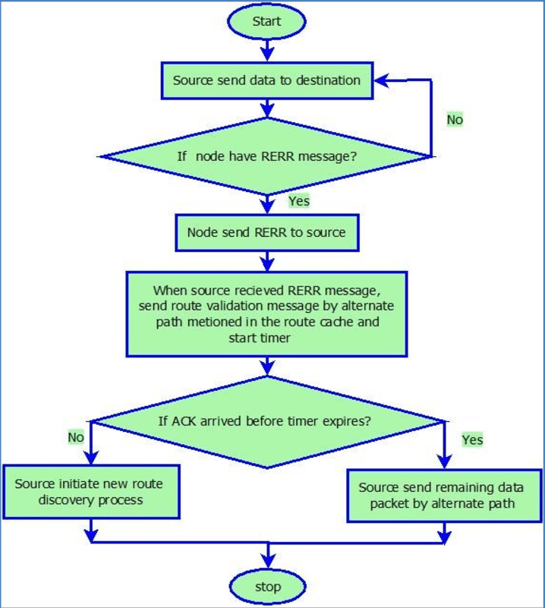
Implementation:
Sample code:
import numpy as np
import pandas as pd
df=pd.read_csv('predictive_maintenance.csv')
df.head()
df.tail()
df.describe()
df.dropna(inplace=True)
fillna(method='ffill', inplace=True)
# Backward fill null values
df.fillna(method='bfill', inplace=True)
print(df)
# Drop columns with any null values
df.dropna(axis=1, inplace=True)
print(df)
stacked_df = df.stack()
# Unstack the dataframe's index
Unstacked_df= df.unstack()
# Transpose the dataframe
transposed_df = df.T
# Stack and unstack together to reshape data
reshaped_df = df.stack().unstack()
# Missing Values Detection
missing_values = df.isnull().sum()
print("Missing Values:")
print(missing_values)
# Data Consistency Check
# Check data types
print("\nData Types:")
print(df.dtypes)
duplicate_rows = df.duplicated().sum()
print(f"\nDuplicate Rows: {duplicate_rows}")
#code for visualization
import io
import numpy as np
import pandas as pd
import matplotlib.pyplot as plt
df=pd.read_csv('/predictive_maintenance.csv')
#Plotting Histogram
plt.figure(figsize=(8,6))
plt.hist(x='Air temperature',alpha=0.7,color='blue',)
plt.xlabel('x-axis')
plt.ylabel('y-axis')
plt.show()
#Plotting Bar chart
plt.figure(figsize=(6, 4))
plt.bar(x='Air temperature',color='blue',alpha=0.3,height=1000)
plt.xlabel('x-axis')
plt.ylabel('y-axis')
plt.show()
import io
import numpy as np
import pandas as pd
import matplotlib.pyplot as plt
import seaborn as sns
df=pd.read_csv('/predictive_maintenance.csv')
#Plotting Scatter plot
sns.scatterplot(data=df,marker='o',color='blue',alpha=0.3)
plt.show()
#Plotting Line graph
sns.lineplot(data=df,color='blue',mec='black')
plt.show()
import io
import numpy as np
import pandas as pd
import matplotlib.pyplot as plt
import seaborn as sns
df=pd.read_csv('/predictive_maintenance.csv')
# Scatterplot Matrix
sns.pairplot(df)
plt.title('Scatterplot Matrix')
plt.show()
import io
import numpy as np
import pandas as pd
import matplotlib.pyplot as plt
import seaborn as sns
import plotly.express as px
df=pd.read_csv('/predictive_maintenance.csv')
# Scatterplot with Plotly
fig = px.scatter_3d(df)
fig.update_layout(title='Interactive 3D Scatter Plot')
fig.show()
#Code for Model development
# Importing necessary libraries
import numpy as np
import pandas as pd
from sklearn.model_selection import train_test_split
from sklearn.ensemble import RandomForestRegressor
from sklearn.metrics import mean_absolute_error

# Generating synthetic data
np.random.seed(42)
num_samples = 1000
num_features = 10
X = np.random.rand(num_samples, num_features) # 1000 samples, 10 features
# Generating a synthetic target variable with some noise
y = 2*X[:,0] + 3*X[:,1]**2 + np.random.normal(0, 0.1, num_samples)

# Splitting data into training and test sets
X_train, X_test, y_train, y_test = train_test_split(X, y, test_size=0.2, random_state=42)

# Training Random Forest model
model = RandomForestRegressor(n_estimators=100, random_state=42)
model.fit(X_train, y_train)

# Predicting on the test set
y_pred = model.predict(X_test)

# Calculating Mean Absolute Error (MAE)
mae = mean_absolute_error(y_test, y_pred)
print('Mean Absolute Error (MAE):', mae)
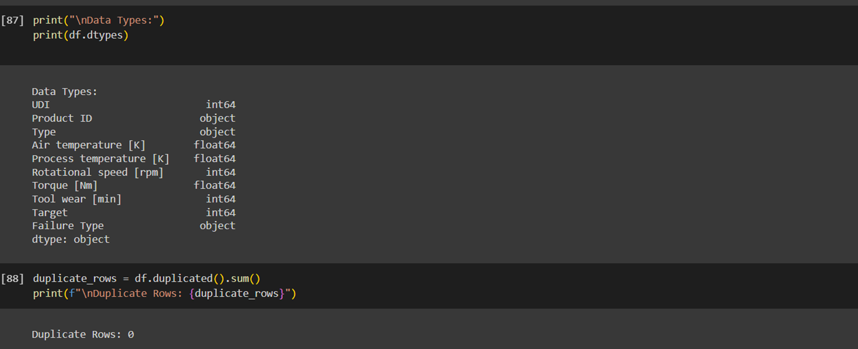
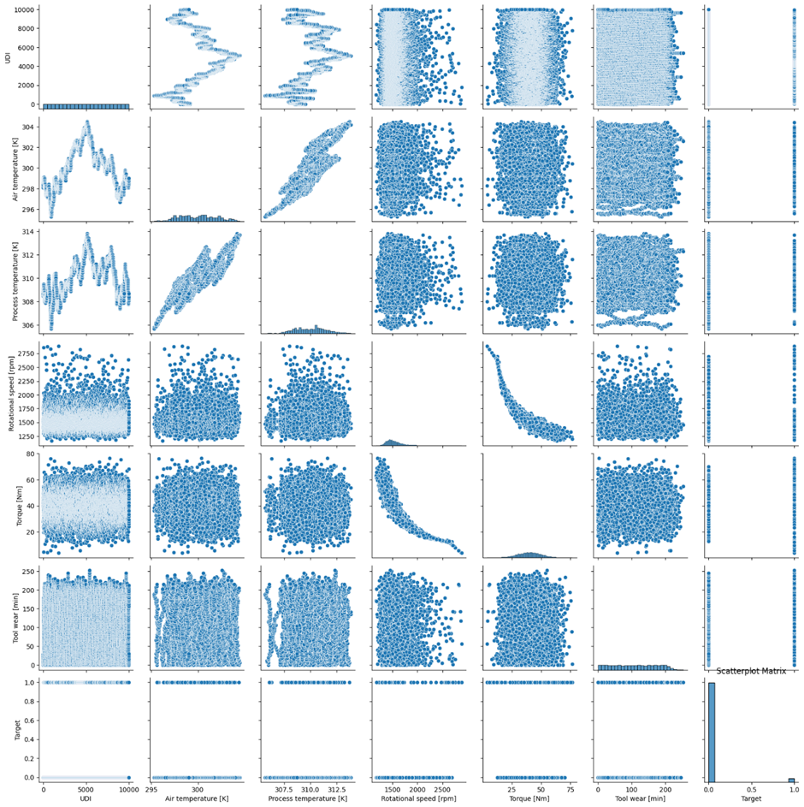
Future enhancement:
- Digital Twin Integration:
  - Concept: A digital twin is a virtual representation of a physical asset or system.
  - Enhancement: Integrating PdM with digital twins allows real-time monitoring, simulation, and testing of maintenance strategies. It enables proactive adjustments based on the digital twin’s behavior.
- Metaverse Integration:
  - Concept: The metaverse is an interconnected virtual space where physical and digital worlds merge.
  - Enhancement: Leveraging the metaverse for PdM enables remote diagnostics, collaboration, and training. Maintenance personnel can interact with virtual assets and perform simulations.
- Generative AI for Synthetic Data:
  - Concept: Generative AI models (e.g., GANs) create synthetic data that resembles real-world data.
  - Enhancement: Generating additional training data using generative models helps address limited datasets. It enhances model robustness and generalization.
Conclusion:
In conclusion, developing a predictive maintenance model involves careful data preprocessing, model selection, and evaluation. By choosing appropriate algorithms like Random Forests or Gradient Boosting and using metrics such as accuracy or MAE, organizations can build effective models to optimize maintenance schedules and minimize downtime, ultimately enhancing asset reliability and performance.

